Merging Development Branch to Main trunk
After getting UAT sign off in Development branch you need to merge these changes in to main trunk.
Follow the following steps for merging CR
- As you wanted to merge in trunk you will need working directory of trunk. So create “trunk_WD” by checking out trunk.
Note:If you already have a trunk working directory update it and resolve any conflicts that arise.
- Right click on trunk_WD → TortoiseSVN → Merge
- Select the option “Merge a range of revisions”
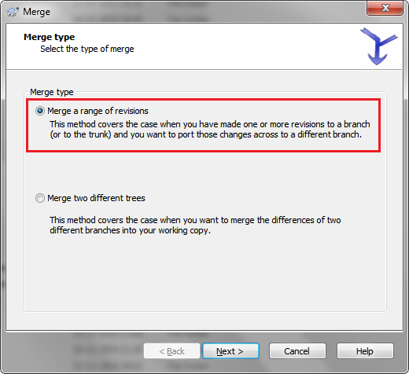

- Click Next
- Specify URL of Development Branch in “URL to merge from” text box
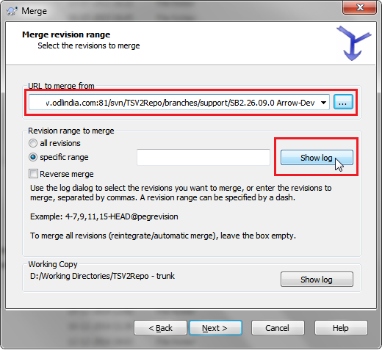
- Let us assume we want to merge changes from CR 2139 only. So Click on the “Show log” button as shown in the above image.

- Enter CR 2139 in the search box, and select the revision numbers which you want to merge as shown below (Select Revision number for CR 2139 only)
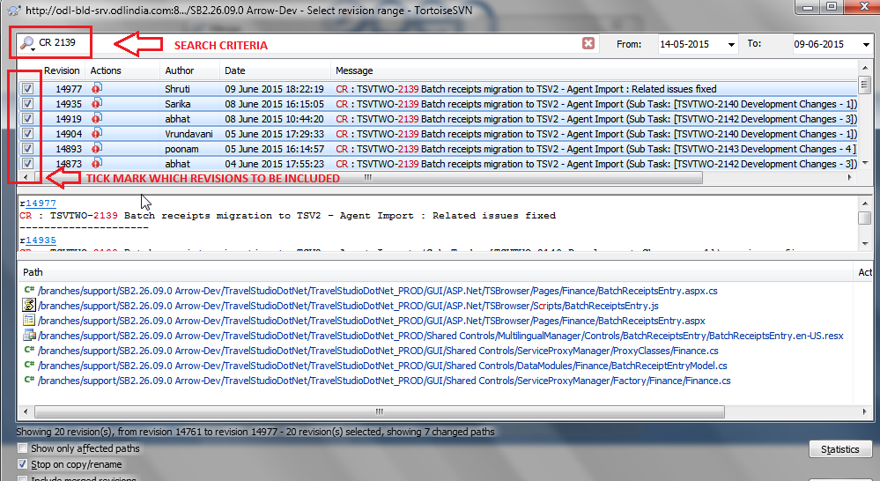

- Click OK
- “Specific range” will now be showing the selected revisions as shown in the below image
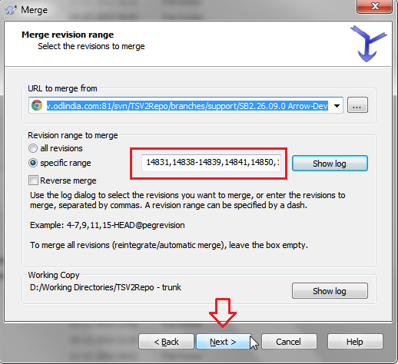
- Click Next and then Merge to finish the Wizard
- Now this has just merged changes from development branch (specific revisions) in your trunk working directory. (at this point merging wont get reflected on server, but only in the local working directory)
- Review the changes, test the functionality (related to CR) and if you are happy with it commit it.
If for some reason there are problems with functionality of the merged copy do not commit. First fix the functionality, test it and then commit (“trunk_WD” → SVN Commit).
- This will apply the merging changes to the trunk branch on the server. Now you have merged changes in “development branch” into the trunk branch.

